Download Art Bento Program @ HiSAM forms at www.hawaiiartsalliance.org or hawaii.gov/sfca/forms. Email lei@hawaiiartsalliance.org to request forms.

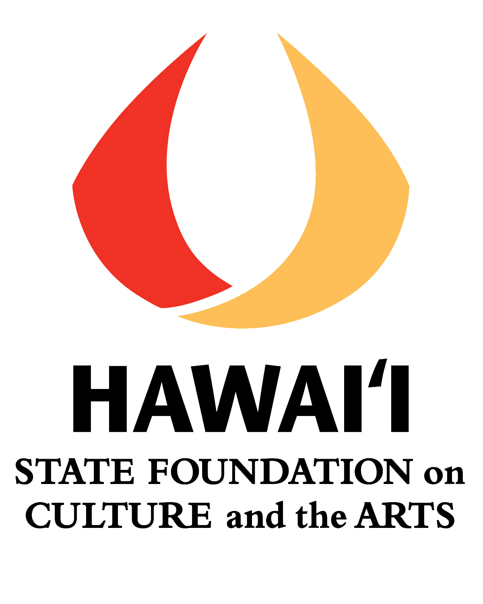
Hawai`i State Foundation on Culture and the Arts
Art Bento Program @ HiSAM
APPLICATION FORM SY 2021-22

Instructions: Please use this form. Type your information and answers in the writeable Word boxes and/or designated spaces for each question. The boxes will expand.
Font size should be no smaller than Arial 10.
Note: We highly recommend a” team approach” when completing this form with the participation/input of at least one representative from each grade level applying.

School Profile
School: | District:
Mailing Address: | Telephone:
Principal:
Email:
Contact Person/Lead Teacher:
Email:
SASA:
Please check if you are a Title I School: , % of students free/reduced lunch ______
Has your school participated in the following two SFCA programs in the past 3 years (SY18-19, SY19-20, SY20-21)?
- Artists in the Schools Program (AITS) - Yes No
Most recent year? _________ Grades that Participated: ______________________

- Art Bento Program @ HiSAM - Yes No
What years or most recent year? _______ Grades that Participated: _____________________

- Other arts education programs conducted at your school (in the last 3 years) and/or arts education professional development provided for staff: Please include years/grade levels participating. ____________________________________________________________

I agree to all the program requirements as stated on the Application Information Sheet.
We have watched the Art Bento Program Presentation PowerPoint on the HSFCA website.
Principal’s Signature:
Contact/Lead Teacher Signature:
Date:

NARRATIVE

Please answer the following questions. The boxes below will expand as you type in them.
Note: Each of the questions, #2 – 6, is worth 5 points. Please refer to the rubric provided.

- Please list and identify the grade levels/and the number of classes that are committed to participating in the Art Bento Program. (Minimum 6 classes, maximum 12).

- How does participating in the arts benefit student learning? How do your teachers implement arts learning in their classrooms? Please cite specific examples. (Worth 5 points)

For 1st time applying schools: Read/Review the Art Bento flier and PowerPoint carefully and cite two ways in which this inquiry-based program will benefit your teachers and students and/or align with your school’s goals. Please cite specific examples. (Worth 5 points)
For repeating schools: 1. What have students and teachers gained as a result of past participation in the program? 2. Provide example(s) of how your teachers have incorporated open-ended questioning, facilitated conversations and visual images into their teaching and/or curriculum as a result of that participation. 3. Describe benefits of further participation for your teachers. Please cite specific examples. (Worth 5 points)

- Describe how your teachers and administration will ensure full participation in each segment of this program while supporting the fulfillment of the program requirements? (Worth 5 points)

- Define and describe the space(s) your school has available and will reserve exclusively for the Visual OR Performing Teaching Artist’s use throughout the Art Bento residency [Pre Visit, Post Visit]. Visual: sink and preferably linoleum floor. Performing: clean, open, and preferably carpeted space. Describe your school’s capacity for providing appropriate DESIGNATED space reserved for each artform (Visual/Performing). (Worth 5 points)

- Additional information you may wish to include to support your application: (worth 5 points)

NOTE: If your school is applying for the 1st or 2nd year and you would like feedback on your application before final submission, please email this document to lei@hawaiiartsalliance.org
by February 26, 2021. FINAL submission of application is due March 12, 2021 by 4:00 pm HST.

